Internal Working of HashMap in Java
In this article, we will see how hashmap’s get and put method works internally. What operations are performed. How the hashing is done. How the value is fetched by key. How the key-value pair is stored.
As in previous article, HashMap contains an array of Node and Node can represent a class having following objects :
- int hash
- K key
- V value
- Node next
Now we will see how this works. First we will see the hashing process.
Hashing
Hashing is a process of converting an object into integer form by using the method hashCode(). Its necessary to write hashCode() method properly for better performance of HashMap. Here I am taking key of my own class so that I can override hashCode() method to show different scenarios. My Key class is
//custom Key class to override hashCode()
// and equals() method
class Key
{
String key;
Key(String key)
{
this.key = key;
}

@Override
public int hashCode()
{
return (int)key.charAt(0);
}

@Override
public boolean equals(Object obj)
{
return key.equals((String)obj);
}
}
Here overrided hashCode() method returns the first character’s ASCII value as hash code. So whenever the first character of key is same, the hash code will be same. You should not approach this criteria in your program. It is just for demo purpose. As HashMap also allows null key, so hash code of null will always be 0.
hashCode() method
hashCode() method is used to get the hash Code of an object. hashCode() method of object class returns the memory reference of object in integer form. Definition of hashCode() method is public native hashCode(). It indicates the implementation of hashCode() is native because there is not any direct method in java to fetch the reference of object. It is possible to provide your own implementation of hashCode().
In HashMap, hashCode() is used to calculate the bucket and therefore calculate the index.
equals() method
equals method is used to check that 2 objects are equal or not. This method is provided by Object class. You can override this in your class to provide your own implementation.
HashMap uses equals() to compare the key whether the are equal or not. If equals() method return true, they are equal otherwise not equal.
Buckets
A bucket is one element of HashMap array. It is used to store nodes. Two or more nodes can have the same bucket. In that case link list structure is used to connect the nodes. Buckets are different in capacity. A relation between bucket and capacity is as follows:
capacity = number of buckets * load factor
A single bucket can have more than one nodes, it depends on hashCode() method. The better your hashCode() method is, the better your buckets will be utilized.
Index Calculation in Hashmap
Hash code of key may be large enough to create an array. hash code generated may be in the range of integer and if we create arrays for such a range, then it will easily cause outOfMemoryException. So we generate index to minimize the size of array. Basically following operation is performed to calculate index.
index = hashCode(key) & (n-1).
where n is number of buckets or the size of array. In our example, I will consider n as default size that is 16.
- Initially Empty hashMap: Here, the hashmap is size is taken as 16.
- HashMap map = new HashMap();
HashMap :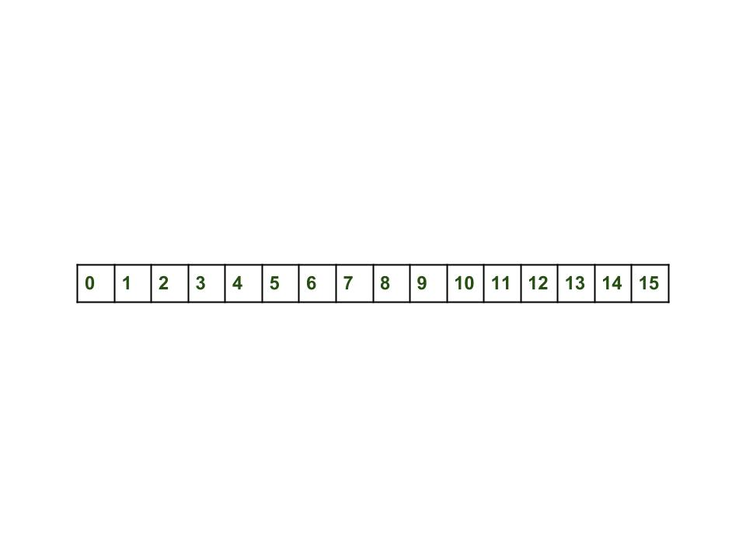
- Inserting Key-Value Pair: Putting one key-value pair in above HashMap
- map.put(new Key("vishal"), 20);
Steps:
  - Calculate hash code of Key {“vishal”}. It will be generated as 118.
  - Calculate index by using index method it will be 6.
  - Create a node object as :
  - {
  - int hash = 118

  - // {"vishal"} is not a string but
  - // an object of class Key
  - Key key = {"vishal"}

  - Integer value = 20
  - Node next = null
}
  - Place this object at index 6, if no other object is presented there.
Now HashMap becomes :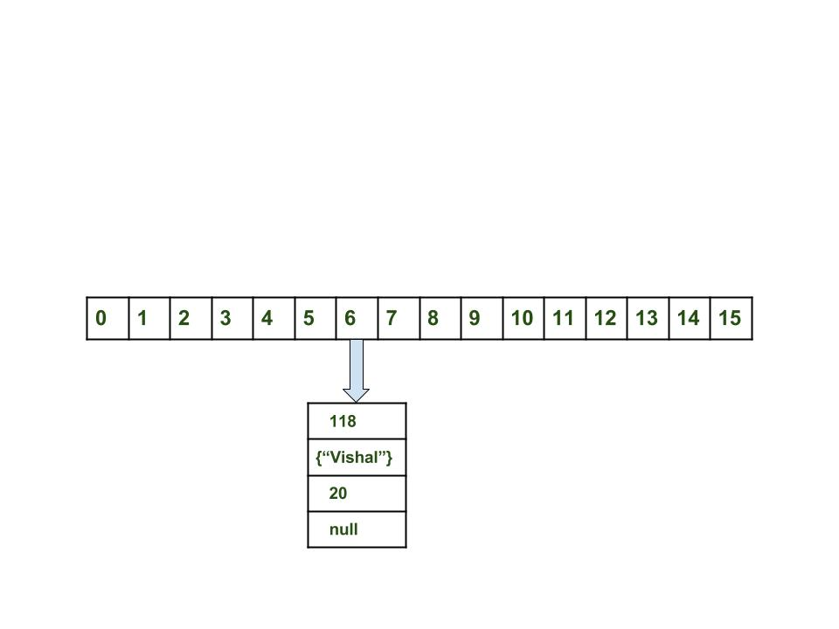
- Inserting another Key-Value Pair: Now, putting other pair that is,
- map.put(new Key("sachin"), 30);
Steps:
  - Calculate hashCode of Key {“sachin”}. It will be generated as 115.
  - Calculate index by using index method it will be 3.
  - Create a node object as :
  - {
  - int hash = 115
  - Key key = {"sachin"}
  - Integer value = 30
  - Node next = null
}
Place this object at index 3 if no other object is presented there.
Now HashMap becomes :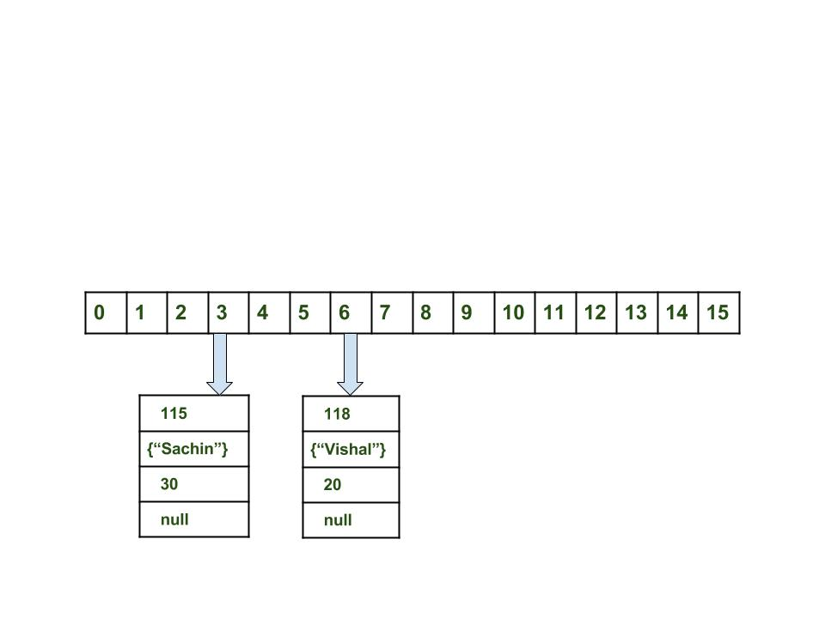

In Case of collision: Now, putting another pair that is,
map.put(new Key("vaibhav"), 40);
Steps:
  - Calculate hash code of Key {“vaibhav”}. It will be generated as 118.
  - Calculate index by using index method it will be 6.
  - Create a node object as :
  - {
  - int hash = 118
  - Key key = {"vaibhav"}
  - Integer value = 40
  - Node next = null
}
  - Place this object at index 6 if no other object is presented there.
  - In this case a node object is found at the index 6 – this is a case of collision.
  - In that case, check via hashCode() and equals() method that if both the keys are same.
  - If keys are same, replace the value with current value.
  - Otherwise connect this node object to the previous node object via linked list and both are stored at index 6.
Now HashMap becomes :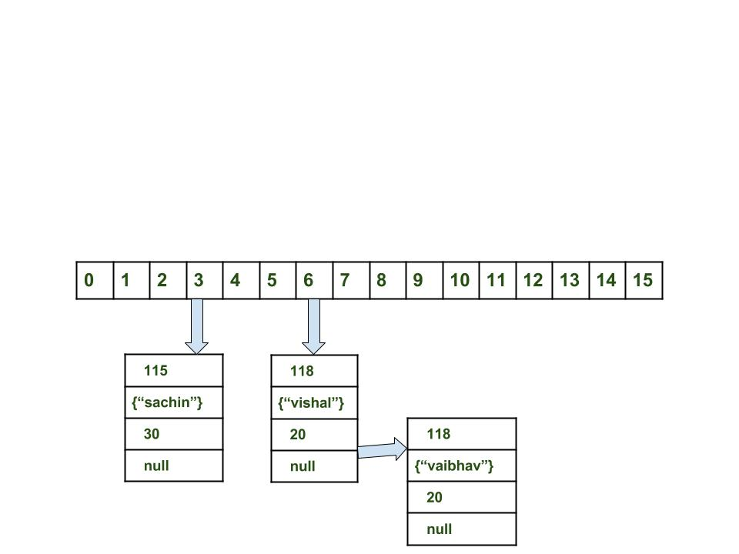
Using get method()
Now lets try some get method to get a value. get(K key) method is used to get a value by its key. If you don’t know the key then it is not possible to fetch a value.
- Fetch the data for key sachin:
- map.get(new Key("sachin"));
Steps:
  - Calculate hash code of Key {“sachin”}. It will be generated as 115.
  - Calculate index by using index method it will be 3.
  - Go to index 3 of array and compare first element’s key with given key. If both are equals then return the value, otherwise check for next element if it exists.
  - In our case it is found as first element and returned value is 30.
- Fetch the data for key vaibahv:
- map.get(new Key("vaibhav"));
Steps:
  - Calculate hash code of Key {“vaibhav”}. It will be generated as 118.
  - Calculate index by using index method it will be 6.
  - Go to index 6 of array and compare first element’s key with given key. If both are equals then return the value, otherwise check for next element if it exists.
  - In our case it is not found as first element and next of node object is not null.
  - If next of node is null then return null.
  - If next of node is not null traverse to the second element and repeat the process 3 until key is not found or next is not null.

// Java program to illustrate
// internal working of HashMap
import java.util.HashMap;

class Key {
String key;
Key(String key)
{
this.key = key;
}

@Override
public int hashCode()
{
int hash = (int)key.charAt(0);
System.out.println("hashCode for key: "
+ key + " = " + hash);
return hash;
}

@Override
public boolean equals(Object obj)
{
return key.equals(((Key)obj).key);
}
}

// Driver class
public class GFG {
public static void main(String[] args)
{
HashMap map = new HashMap();
map.put(new Key("vishal"), 20);
map.put(new Key("sachin"), 30);
map.put(new Key("vaibhav"), 40);

System.out.println();
System.out.println("Value for key sachin: " + map.get(new Key("sachin")));
System.out.println("Value for key vaibhav: " + map.get(new Key("vaibhav")));
}
}
Output:
hashCode for key: vishal = 118
hashCode for key: sachin = 115
hashCode for key: vaibhav = 118

hashCode for key: sachin = 115
Value for key sachin: 30
hashCode for key: vaibhav = 118
Value for key vaibhav: 40
HashMap Changes in Java 8
As we know now that in case of hash collision entry objects are stored as a node in a linked-list and equals() method is used to compare keys. That comparison to find the correct key with in a linked-list is a linear operation so in a worst case scenario the complexity becomes O(n).
To address this issue, Java 8 hash elements use balanced trees instead of linked lists after a certain threshold is reached. Which means HashMap starts with storing Entry objects in linked list but after the number of items in a hash becomes larger than a certain threshold, the hash will change from using a linked list to a balanced tree, which will improve the worst case performance from O(n) to O(log n).
Important Points
  - Time complexity is almost constant for put and get method until rehashing is not done.
  - In case of collision, i.e. index of two or more nodes are same, nodes are joined by link list i.e. second node is referenced by first node and third by second and so on.
  - If key given already exist in HashMap, the value is replaced with new value.
  - hash code of null key is 0.
  - When getting an object with its key, the linked list is traversed until the key matches or null is found on next field.

Understanding How hashCode() Works
Simply put, hashCode() returns an integer value, generated by a hashing algorithm.
Objects that are equal (according to their equals()) must return the same hash code. It's not required for different objects to return different hash codes.
The general contract of hashCode() states:
- Whenever it is invoked on the same object more than once during an execution of a Java application, hashCode() must consistently return the same value, provided no information used in equals comparisons on the object is modified. This value needs not remain consistent from one execution of an application to another execution of the same application
- If two objects are equal according to the equals(Object) method, then calling the hashCode() method on each of the two objects must produce the same value
- It is not required that if two objects are unequal according to the equals(java.lang.Object) method, then calling the hashCode method on each of the two objects must produce distinct integer results. However, developers should be aware that producing distinct integer results for unequal objects improves the performance of hash tables
“As much as is reasonably practical, the hashCode() method defined by class Object does return distinct integers for distinct objects. (This is typically implemented by converting the internal address of the object into an integer, but this implementation technique is not required by the JavaTM programming language.)”

4. A Naive hashCode() Implementation
It’s actually quite straightforward to have a naive hashCode() implementation that fully adheres to the above contract.
To demonstrate this, we’re going to define a sample User class that overrides the method’s default implementation:
1  2  3  4  5  6  7  8  9  10  11  12  13  14  15  16  17  18  19  20  21  22  23  24  25  26 | public class User {  private long id;  private String name;  private String email;  // standard getters/setters/constructors  @Override  public int hashCode() {  return 1;  }  @Override  public boolean equals(Object o) {  if (this == o) return true;  if (o == null) return false;  if (this.getClass() != o.getClass()) return false;  User user = (User) o;  return id == user.id  && (name.equals(user.name)  && email.equals(user.email));  }  // getters and setters here  }
The User class provides custom implementations for both equals() and hashCode() that fully adhere to the respective contracts. Even more, there's nothing illegitimate with having hashCode() returning any fixed value.
However, this implementation degrades the functionality of hash tables to basically zero, as every object would be stored in the same, single bucket.
In this context, a hash table lookup is performed linearly and does not give us any real advantage – more on this in section 7.

5. Improving the hashCode() Implementation
Let's improve a little bit the current hashCode() implementation by including all fields of the User class so that it can produce different results for unequal objects:
1  2  3  4 | @Override  public int hashCode() {  return (int) id * name.hashCode() * email.hashCode();  }
This basic hashing algorithm is definitively much better than the previous one, as it computes the object's hash code by just multiplying the hash codes of the name and email fields and the id.
In general terms, we can say that this is a reasonable hashCode() implementation, as long as we keep the equals() implementation consistent with it.

6. Standard hashCode() Implementations
The better the hashing algorithm that we use to compute hash codes, the better will the performance of hash tables be.
Let's have a look at a “standard” implementation that uses two primes numbers to add even more uniqueness to computed hash codes:
1  2  3  4  5  6  7  8 | @Override  public int hashCode() {  int hash = 7;  hash = 31 * hash + (int) id;  hash = 31 * hash + (name == null ? 0 : name.hashCode());  hash = 31 * hash + (email == null ? 0 : email.hashCode());  return hash;  }
While it's essential to understand the roles that hashCode() and equals() methods play, we don't have to implement them from scratch every time, as most IDEs can generate custom hashCode() and equals() implementations and since Java 7, we got an Objects.hash() utility method for comfortable hashing:

